# GDA94 to GDA2020 transformation grids development summary

## Overview

There are vast quantities of digital spatial data stored throughout Australia. This data is collected, managed and used by a wide variety of organisations and for a diverse range of applications. Until recently, most spatial data in Australia has been related to the Geocentric Datum of Australia 1994 (GDA94). In October 2017, the new Geocentric Datum of Australia 2020 (GDA2020) [EPSG: 1168] was officially defined in the National Measurement (Recognized-Value Standard of Measurement of Position) Determination 2017. ANZLIC – the Spatial Information Council of Australia and New Zealand announced 30 June 2020 as the date by which Australian State and Territories will support the delivery and receipt of foundational spatial data on the GDA2020 datum.

The transition from GDA94 to GDA2020 will see coordinates shift by approximately 1.5m - 1.8m in a north-easterly direction due to the motion of the Australian tectonic plate. In adopting GDA2020, those involved in the collection, management, distribution and provision of spatial data will need to manage the issues associated with the transformation of data between the old and new datum.

To support transformation of spatial data between GDA94 and GDA2020, transformation products were developed that were simple to apply, computationally efficient, unique in terms of the solution and rigorous in application. The Intergovernmental Committee on Surveying and Mapping (ICSM) developed three transformation products, including:

* 3D 7-parameter similarity (Helmert) transformation (conformal) [EPSG: 8048]
* 2D conformal NTv2 grid file [EPSG: 8446]
* 2D conformal + distortion NTv2 grid file [EPSG: 8447]]

Figure 1 shows the extents of the two national transformation grids.

Please note, due to the way Queensland maintained the GDA94 coordinates of survey control marks, there is effectively no distortion modelled in Queensland and the conformal + distortion grid reverts to the conformal-only grid across the state.

Additional two-dimensional conformal-only transformation grids were developed for the Indian Ocean Territories:

* Christmas Island [EPSG: 8444]
* Cocos (Keeling) Islands [EPSG: 8445]

Conformal + distortion transformation grids were not developed for the Indian Ocean Territories.

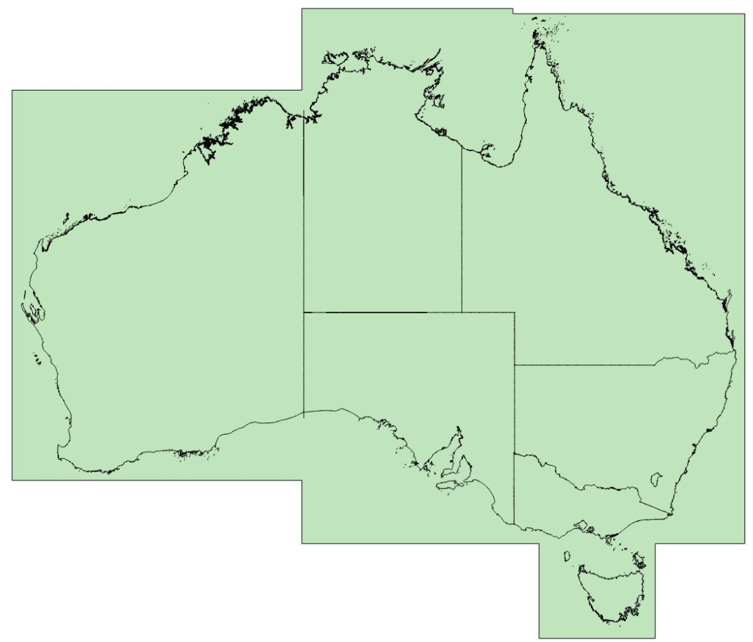

Figure 1. National transformation grid extents

In addition to the transformation products, ICSM also prepared the Geocentric Datum of Australia 2020 Technical Manual to summarise technical information related to the definition of GDA2020, transformation and coordinate conversion options, and the relationship to the Australian Height Datum (AHD). In addition to the GDA2020 Technical Manual summary of coordinate transformation, this report details the development of the conformal + distortion grid, including refinements to the input data, parameters and modelling approach.

The GDA2020 Technical Manual includes recommendations for selecting the appropriate transformation method. Additional advice is provided in section 2 of this report, with a flow chart presented to identify the most suitable transformation option based on spatial data accuracy and origin.

## Selection of transformation grid

The spatial accuracy and origin of spatial data are important considerations when selecting the appropriate transformation approach. This includes the option to not transform data if it is considered GDA2020 compatible.

The seven-parameter conformal transformation is a three-dimensional transformation and is applied to three-dimensional data (Cartesian XYZ or latitude, longitude and ellipsoidal height). It accounts for tectonic plate motion and is recommended for transforming spatial data directly related to Global Navigation Satellite System (GNSS) observations, with no influence from the local survey control mark network.

For two-dimensional data, the conformal-only grid replicates the behaviour of the seven-parameter conformal transformation and is designed to suit the transformation of data derived from GNSS observations, with no influence from the local survey control mark network.

The conformal + distortion grid supports transformation of two-dimensional data derived through a connection to the survey control mark network and thus subject to the influence of distortion that exists between adjusted GDA94 and GDA2020 survey control mark coordinates. The two-dimensional transformation grids are applied to geographical coordinates (latitude and longitude).

The conformal-only grid is most suitable when transforming two-dimensional spatial data within Queensland, and the conformal + distortion grid is identical to the conformal-only grid, one grid cell within the Queensland state border. Care should be exercised when transforming spatial data that overlaps two kilometres within the Queensland border.

Spatial data accuracy is also an important consideration when selecting which GDA94-GDA2020 transformation method to apply. Figure 2 supports the selection of the appropriate transformation option for two-dimensional datasets, taking into account spatial data horizontal accuracy and origin.

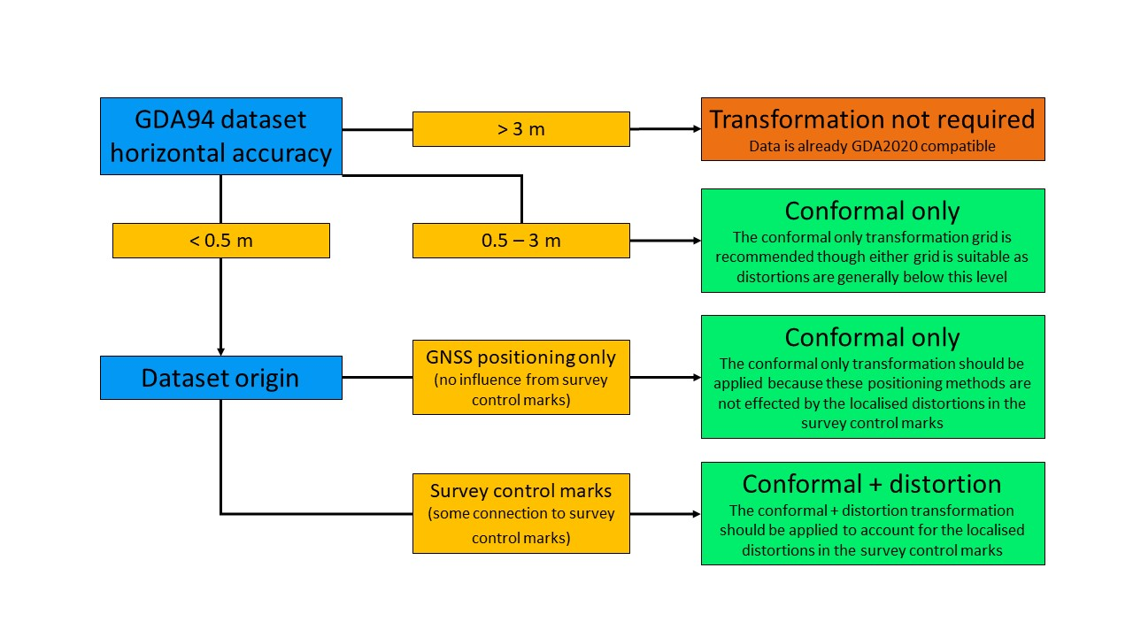

Figure 2. Transformation decision making flow chart

Please note that all transformation methods have a degree of uncertainty which flows through to the final transformed spatial data. Also, AHD remains the official national height datum. The datum transformation options should not affect the orthometric height of spatial data.

The following sections summarise the development of the primary transformation products between GDA94 and GDA2020.

## Seven-parameter conformal transformation

Geoscience Australia derived official conformal transformation parameters between GDA94 and GDA2020. The seven transformation parameters were derived in the Combination and Analysis of Terrestrial Reference Frame (CATREF) software. The best-fit parameters were computed for the transformation between 18 nationally distributed GNSS Continuously Operating Reference Stations (CORS) that feature in both the GDA94 and GDA2020 National Measurement Institute (NMI) Recognised Value-Standard of Measurement of Position Determinations.

The seven-parameter conformal transformation represents the fundamental change in the datum, defined by the official GNSS CORS positions. This effectively accounts for the observed 70 mm per year motion of the Australian tectonic plate between 1994 and 2020 and change in underlying reference frame from ITRF1992 to ITRF2014. It is important to note that the scale change between ITRF1992 and ITRF2014 resulted in a 90mm – 100mm reduction in ellipsoidal heights across Australia with the transition from GDA94 to GDA2020. This consistent change in ellipsoidal height is accommodated in the AUSGeoid2020 model. For this reason, AUSGeoid2020 is the model required to derive AHD heights from GDA2020 ellipsoidal heights and is not compatible with GDA94. To derive AHD heights from GDA94 ellipsoidal heights the AUSGeoid09 model is required.

The seven transformation parameters consist of three translations, three rotations and one scale, and are published in the GDA2020 Technical Manual. This coordinate transformation approach is designed for three-dimensional data which is free from the distortion in the survey control mark network, such as GNSS positioning data.

## Conformal-only transformation grid

The conformal-only grid replicates the behaviour of the seven-parameter transformation. This 1’ x 1’ national grid is provided in the Canadian National Transformation version 2 (NTv2) format.

The conformal-only grid is suitable for the transformation of two-dimensional data derived from GNSS data aligned to a CORS network (e.g. CORSnet-NSW, GPSnet, AUSPOS) and not corrected for localised distortions related to the survey control mark network.

## Conformal + distortion transformation grid

The conformal + distortion grid attempts to extend upon the conformal-only grid, accounting for the distortion that exists between the realisation of GDA94 and GDA2020 in the survey control mark network. The conformal + distortion grid was developed using survey control network marks at which both GDA94 and GDA2020 coordinates were defined. The distortion component was modelled from the difference between nationally adjusted GDA2020 coordinates and GDA2020 coordinates derived by applying the conformal-only transformation to jurisdiction supplied GDA94 coordinates.

Distortion = GDA2020 (national adjustment) – GDA2020 (conformal-only transformed GDA94)

With the move to GDA2020, Australia is transitioning from a state-based GDA94 adjustment approach to a national GDA2020 adjustment approach. One of the motivating drivers behind this modernisation was to mitigate the occurrence of distortion in GDA94. In some cases, the magnitude of distortion between GDA94 and GDA2020 is in the order of decimetres and can be attributed to a range of factors, including:

* change in the least-squares adjustment approach from non-contiguous, jurisdiction based to a contiguous national adjustment
* application of constraint in different ways for jurisdictional GDA94 adjustments
* influence of additional measurements and changed network geometry
* influence of additional measurements from neighbouring jurisdictions in the GDA2020 national adjustment
* surface deformation and monument instability over time

The objective of including modelled distortion is to account for changes in network shape (represented in the survey control mark adjusted coordinates) and thereby improve the level of agreement between the adjusted and transformed coordinates. The conformal + distortion grid is recommended for GDA94 data aligned with survey control network marks.

Modelling of distortion between adjusted survey control mark coordinates across Australia was complicated as distortion can be highly variable in magnitude, direction and distribution. The conformal + distortion grid went through several revisions during development, with changes made to input data, modelling parameters and strategies. These revisions were performed to improve the national model by removing outliers and/or incorporating additional control marks into the distortion modelling procedure.

There are various distortion modelling techniques available, such as minimum curvature surfaces, least squares collocation and multiple regression equations. The least squares collocation distortion modelling approach was adopted for development of the GDA94 to GDA2020 conformal + distortion grid. Throughout this document references to the “model” or “modelling approach” refer to the least squares collocation method used by the GDAGrid software to estimate distortion at each grid node. This distortion modelling approach was deemed most suitable for modelling network distortion in the Australian context and was the same technique used to develop the AGD66/84 and GDA94 transformation grids.

GDAGrid is scientific software and not publicly available. The software was originally developed through the University of Melbourne for distortion modelling and creation of the transformation grids between AGD66/84 and GDA94. The GDAGrid software was upgraded by a consultant to support the development of the conformal + distortion grid between GDA94 and GDA2020.

## Least squares collocation

Least squares collocation, when applied to distortion modelling, is a weighted interpolation process. This technique applies weighted distortion at surrounding survey marks to estimate distortion at grid nodes. The approach involves development of a distance-dependent covariance function to represent the spatial behaviour of distortion in two-dimensions (East and North). The computation of the covariance function was based on assigned parameters determined through a cross validation testing process.

## Outlier detection and removal

The accuracy of the distortion model is dependent on the consistency (in magnitude and direction) of the distortion at the informing marks selected to predict the distortion at a grid node. Occasional outliers or “non-conforming points” have been found to impact the distortion modelling in unpredictable and counterintuitive ways.

An outlier detection and removal process were conducted before the distortion modelling procedure was undertaken. A mark was considered an outlier if the GDA94 coordinates transformed to GDA2020 using the conformal-only grid were different to the GDA2020 national adjustment coordinates by more than a specified value. Initially this value was set at 250 mm. Whilst under normal circumstances 250 mm would be considered an outlier, such magnitudes could be considered a true representation of the distortion in some areas. The net result of the arbitrary outlier removal approach was that the distortion grid nodes in those areas were produced with a conformal-only component and thereby, the transformation failed to apply the expected distortion in the GDA94 coordinates.

To overcome this problem, all State and Territory jurisdictions were supplied a list of detected outliers. Jurisdictions confirmed which of these survey marks represented genuine outliers and which survey marks should be maintained in the distortion modelling procedure.

## Weighting of distortion

The survey marks supplied across Australia in the distortion modelling procedure were highly variable in spatial distribution. After the outlier detection and removal process a thinning process was performed on marks which were within 5 m of each other. This thinning process was performed to reduce the influence of highly clustered networks of survey marks.

If two marks were within 5 m of each other, the GDA2020 national adjustment uncertainty for both marks were compared. The mark with the lower uncertainty estimate was retained and the other mark removed from the model. However, if two marks were more than 5 m from each other, they were both retained in the model and contributed the same level of influence on the distortion model. That is, there was no weighting applied based on the GDA2020 uncertainty estimates. As such, State and Territory jurisdictions identified survey marks with high uncertainty to be withdrawn so they did not influence the distortion model.

## Correlation length

An empirically derived covariance function was not applied in the distortion modelling procedure. Rather a correlation length parameter (32 km) and search radius parameter (80 km) were specified for the covariance function. The correlation length parameter (32 km) used in the model effectively determined the distance (~45 km) within which an informing survey mark would influence the predicted grid node and the other informing marks. The search radius parameter (80 km) limited the range within which informing survey marks could contribute to the distortion modelling at each grid node.

A best-fitting distortion correlation length of approximately 6 km was originally computed for the national dataset, based on a statistical analysis to determine the distance at which the distortion of marks was correlated. However, areas without marks within the reach of the distortion correlation length, reverted to the conformal-only transformation component. This led to a relatively spotty looking distortion grid, particularly in regional areas where marks were sparsely distributed. Further, there were cases where distortion modelling was not being performed around marks, even though those marks were not considered outliers. This was due to a step in the distortion modelling which prevented the determination of an estimate of distortion if only one mark fell within a grid area.

To expand the modelling of distortion and include more marks in the distortion modelling procedure, the statistically determined correlation length and search radius parameters were over-written to be 32 km and 80 km, respectively. These parameters were selected based on distortion modelling cross validation tests.

## Cross validation testing

The choice of a suitable correlation length was difficult for a national dataset such as this where there are densely clustered marks (such as in towns and cities) and sparsely distributed marks (such as in regional areas), as well as inconsistent levels of distortion (magnitude and direction).

Distortion modelling cross validation testing was performed for ten different combinations of correlation length (4 km, 8 km, 16 km, 32 km, 64 km) and search radius (20 km, 80 km) parameters. These parameters were varied to improve the distortion modelling and capture more points in the model. Results from the separate cross validation tests were compared to identify the optimum parameter combination.

Table 1. Summary statistic for different parameter combinations

|  |  |  |  |  |  |  |  |  |  |  |  |
| --- | --- | --- | --- | --- | --- | --- | --- | --- | --- | --- | --- |
|  | **Mean** |  | **Sdev** |  | **Min** |  | **Max** |  | **No Result** | | **Outliers** |
| **Name** | **Lat** | **Long** | **Lat** | **Long** | **Lat** | **Long** | **Lat** | **Long** | **Lat** | **Long** | **Count** |
| Xval_4k_20k | 0.000 | -0.004 | 0.023 | 0.032 | -0.126 | -0.187 | 0.140 | 0.197 | 6662 | 6662 | 389 |
| Xval_4k_80k | 0.000 | -0.004 | 0.023 | 0.032 | -0.126 | -0.187 | 0.140 | 0.197 | 6390 | 6390 | 385 |
| Xval_8k_20k | -0.001 | -0.003 | 0.021 | 0.027 | -0.180 | -0.165 | 0.125 | 0.120 | 2848 | 2848 | 578 |
| Xval_8k_80k | -0.001 | -0.003 | 0.021 | 0.027 | -0.203 | -0.179 | 0.125 | 0.120 | 2479 | 2479 | 595 |
| Xval_16k_20k | 0.001 | 0.002 | 0.018 | 0.022 | -0.092 | -0.158 | 0.124 | 0.126 | 1384 | 1384 | 803 |
| Xval_16k_80k | 0.001 | 0.003 | 0.018 | 0.021 | -0.092 | -0.158 | 0.124 | 0.126 | 410 | 410 | 922 |
| Xval_32k_20k | 0.001 | 0.002 | 0.016 | 0.019 | -0.111 | -0.148 | 0.120 | 0.140 | 1384 | 1384 | 911 |
| **Xval_32k_80k** | **0.001** | **0.002** | **0.017** | **0.019** | **-0.154** | **-0.146** | **0.120** | **0.140** | **46** | **46** | **1067** |
| Xval_64k_20k | 0.000 | 0.001 | 0.016 | 0.018 | -0.135 | -0.147 | 0.119 | 0.142 | 1384 | 1384 | 917 |
| Xval_64k_80k | 0.000 | 0.001 | 0.016 | 0.018 | -0.104 | -0.147 | 0.119 | 0.142 | 25 | 25 | 1068 |

The mean and standard deviation values for the different tests were quite similar. Likewise, there was little variation in the max and min differences. The “no result” counts were quite large for many of the combinations ranging from 1000 to 6000 points not being included in the distortion modelling. The larger correlation lengths (16 km, 32 km and 64 km) reduced the number of “no result” points. However, this led to an increase in the count of outliers (distortion difference greater than 3-sigma).

A correlation length of 32 km and search radius of 80 km were selected. The larger correlation length of 32 km included more marks in the model and allowed the influence of distortion at marks to extend over distances larger than 45 km, out to the limit of the search radius of 80 km (Figure 3). This led to an increase in the number of marks exhibiting inconsistent distortion behaviour. Whilst the influence of an outlier (in terms of geometry) may have been weak, it could have unpredictable effects.

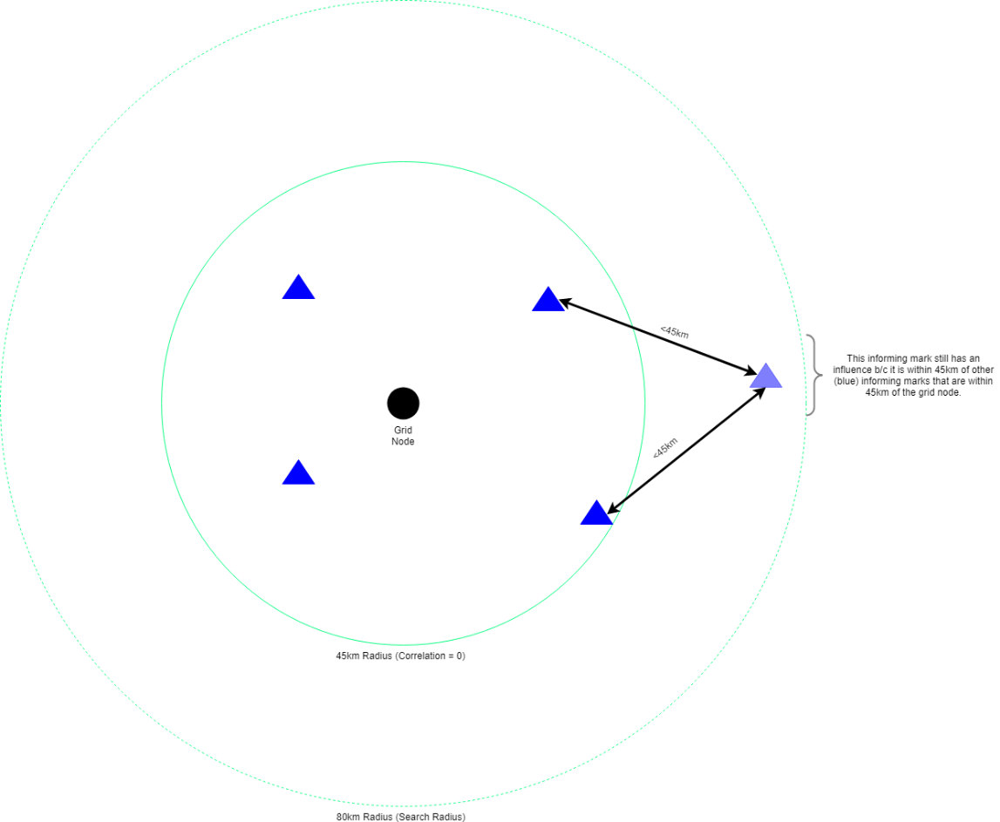

Figure 3. Correlation length and search radius

During this analysis it was observed, that in areas where distortion is consistent in direction and magnitude the distortion is modelled well (Figure 4). However, if the distortion is inconsistent in direction and magnitude then the distortion can be modelled poorly (Figure 5).

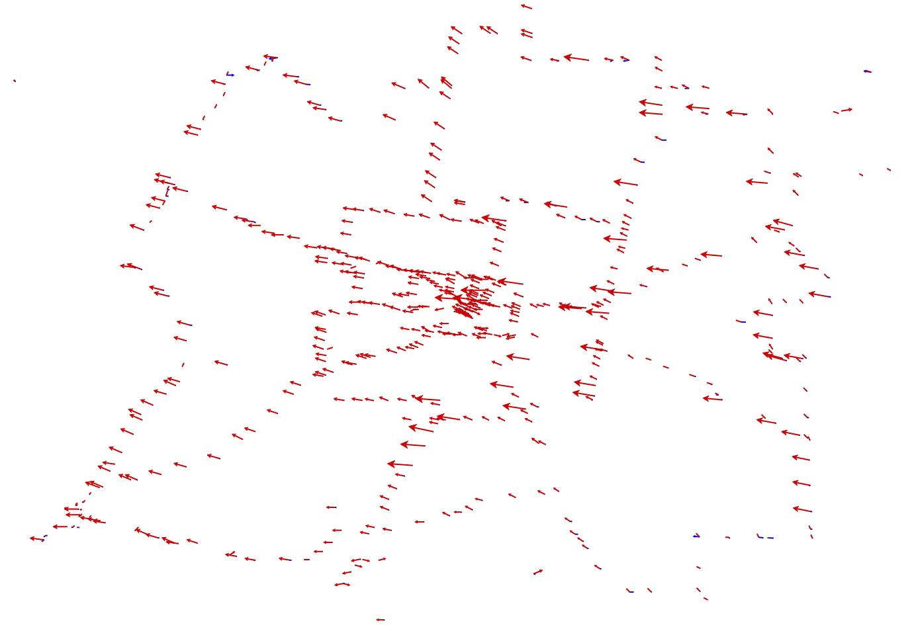

Figure 4. Example of consistent distortion behaviour and the minimal influence on modelled distortion (Hamilton, VIC)

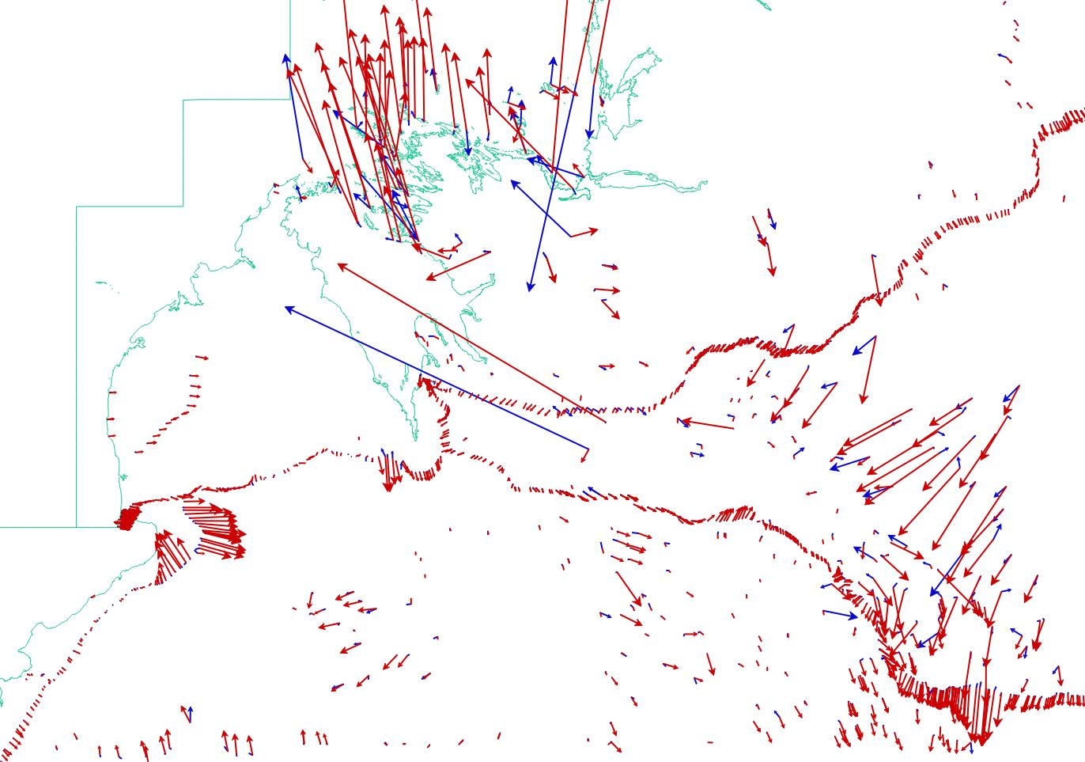

Figure 5. Example of consistent and inconsistent distortion behaviour and the influence on modelled distortion (North West WA)

## Point selection

To predict the distortion at a grid node the software selects a number (5) of informing marks to use in the prediction. The algorithm used to perform this task is shown in Figure 6 and described below:

1. All informing marks within a certain radius (80 km) of the grid node are identified.
2. Identify the closest informing mark to the grid node and record its quadrant (e.g. Quadrant 1)
   1. *Select this informing survey mark for use in the prediction.*
3. Loop through the remaining quadrants (Q2, Q3, Q4)
   1. *Identify the closest informing survey mark to the grid node in the current quadrant*
   2. *Select this informing survey mark for use in the prediction.*
   3. *If there is no informing mark in this quadrant, move to the next quadrant.*
4. Continue Step 3 until the required number of informing marks are selected.
   1. *Or, stop if there are no more informing marks to check within the 80km.*

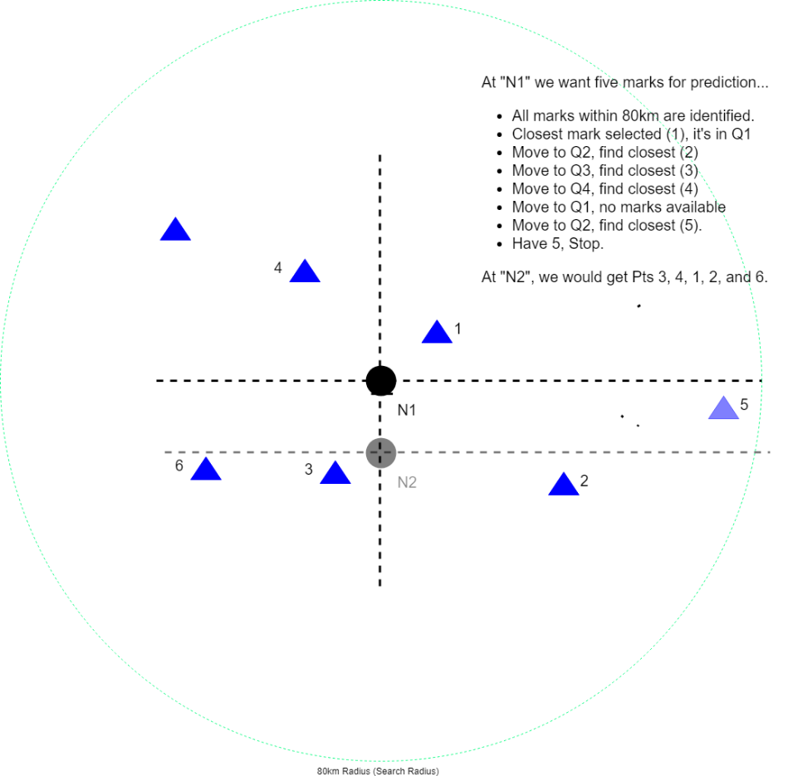

Figure 6: Point Selection

The purpose of quadrant control in this algorithm is to ensure (where possible) that the selected informing marks have a good geometric spread.

The quadrant control process has had an influence in the creation of apparent linear artefacts, caused by the discontinuous selection of informing mark. The inclusion of outliers exacerbated the unpredictable behaviour seen in the distortion modelling.

## Least squares collocation prediction equation

After developing the covariance function, the least squares collocation prediction equation was used to compute the grid of distortion values over Australia.

## National grid

The GDAGrid software and NTv2 grid file format are capable of supporting sub grids. The AGD66/AGD84-GDA94 distortion grids included sub grids. However, in the early development stages of the GDA94-GDA2020 transformation grids, it was decided to generate only one national grid.

Initially the transformation grids were developed as a series of regional grids, covering one or two states/territories. This was done to keep the file sizes small during the development and testing phases. Towards the end of the grid development all the grids were merged into one national grid file (conformal-only, conformal + distortion).

## Queensland conformal-only

The conformal + distortion grid combination was complicated by the requirement for Queensland to only be covered by the conformal-only grid. This is due to the approach Queensland employed for the maintenance of GDA94 survey control mark coordinates via a least-squares adjustment aligned to the most current solution for the GNSS CORS. This approach effectively removed the requirement for the modelling of distortion across Queensland.

The official Queensland state border was used to remove Queensland from the conformal + distortion grid, leaving the conformal-only grid to cover the state. This strategy ensured that distortion would be modelled entirely within neighbouring states and territories. However, the first grid cell within the Queensland border retained the modelled distortion. Therefore, care should be exercised when transforming spatial data that overlaps two kilometres within the Queensland border. The conformal-only transformation grid is recommended for the transformation of two-dimensional spatial data within Queensland.

## Territory transformation grid

Additional two-dimensional conformal-only transformation grids were developed for the Indian Ocean Territories, Christmas Island and Cocos (Keeling) Island. Conformal + distortion transformation grids were not developed for the Indian Ocean Territories.

## Pseudo points

To overcome problems associated with an insufficient number of points, pseudo points were used in the AGD66/AGD84-GDA94 transformation grids development procedure. Pseudo points were not used in the GDA94-GDA2020 distortion modelling procedure. The extended correlation length and search radius overcame the need for introducing pseudo points.

## Performance of the transformation grids

Analysis was performed by each State and Territory jurisdiction to assess the performance of the two transformation grids. The survey control mark data supplied to create the conformal + distortion grid and additional survey control mark data, withheld from the conformal + distortion grid, were used to test the transformation grids.

The transformation grids were found to be fit for purpose, although it was noted that the distortion modelling using the least squares collocation technique was impeded when the distortion was erratic and non-homogenous in behaviour.

## Summary

The transformation grids were accepted by all States and Territories at the end of 2017. The grids were distributed as part of the release and implementation of GDA2020. The conformal-only grid was accepted as a satisfactory product for performing a seven-parameter transformation between GDA94 and GDA2020.

The conformal + distortion grid was developed to provide a best fitting solution across Australia and was deemed fit for purpose by all States and Territories. Various factors and decisions influenced the distortion modelling process, including:

* Variability in distortion (magnitude and direction)
* Variability in the distribution of marks
* Avoidance of sub-grids and adoption of one national grid
* Expectations that distortion be modelled across areas of sparse coverage, beyond the distance at which the distortion of marks was estimated to be correlated (increased the correlation length and search radius)
* Lack of weighting of distortion
* Intentional retention of marks exhibiting inconsistent distortion (e.g. outliers)

The conformal + distortion grid was deemed fit for purpose by all States and Territories. The GDA2020 national adjustment continues to extend and improve as new measurements are introduced, and outliers are resolved. As such the national adjustment derived GDA2020 coordinates of survey control marks are subject to ongoing revision. However, there are no plans to continually revise the conformal + distortion grid. This will slowly degrade the alignment of the conformal + distortion grid with the survey control mark coordinates.

## References

ICSM, 2020, Geocentric Datum of Australia 2020 Technical Manual, Version 1.3.